**DETETIVE DAS LETRAS**



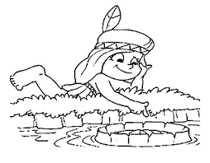

|  |  |  |  |
| --- | --- | --- | --- |
|  | O |  | O |

|  |  |  |  |
| --- | --- | --- | --- |
|  | O |  | A |

|  |  |  |  |  |
| --- | --- | --- | --- | --- |
| R | P | T | B | S |

________________________________________________________________

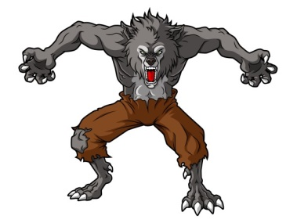

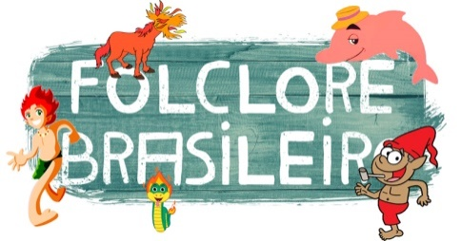

|  |  |  |  |  |  |  |  |  |
| --- | --- | --- | --- | --- | --- | --- | --- | --- |
|  | O |  | I |  | O |  | E |  |

|  |  |  |  |  |
| --- | --- | --- | --- | --- |
| S | M | T | B | L |

__________________________________________________